Assignment 4A

Name: Aryan Vora
Roll No: 33302
Batch: K-11

index.hmtl
<!DOCTYPE html>
<html lang="en">

<head>
<meta charset="UTF-8">
<meta http-equiv="X-UA-Compatible" content="IE=edge">
<meta name="viewport" content="width=device-width, initial-scale=1.0">
<link rel="stylesheet" href="https://code.jquery.com/mobile/1.4.5/jquery.mobile-
1.4.5.min.css" />
<script src="https://code.jquery.com/jquery-1.11.1.min.js"></script>
<script src="https://code.jquery.com/mobile/1.4.5/jquery.mobile-1.4.5.min.js"></script>
<title>Demo of jQuery Mobile</title>
</head>

<body>
<div data-role="page" style="background-color:aliceblue;">
<div data-role="header" style="background-color: #2196F3; color: #fff; text-align: center;">
<h1 style="font-size: 24px;">Furniture For You</h1>
</div>
<div data-role="navbar" style="background-color: #f5f5f5;">
<ul>
<li><a href="index.html" style="color: #666;">Home</a></li>
<li><a href="about.html" style="color: #666;">About</a></li>
<li><a href="login_register.html" style="color: #666;">Register for Newsletter</a></li>
</ul>
</div>

<center>
<h3>Gallery</h3>
</center>
<div class="content">
<center>
<div class="rows">
<img src="img1.jpg" alt="Img1" width="240" height="200">
<img src="img2.jpg" alt="Img2" width="240" height="200">
<img src="img3.jpg" alt="Img3" width="240" height="200">
<img src="img4.jpg" alt="Img4" width="240" height="200">
<img src="img5.jpg" alt="Img4" width="240" height="200">
<img src="img6.jpg" alt="Img4" width="240" height="200">
</div>
<br>
<div class="rows">
<img src="img1.jpg" alt="Img1" width="240" height="200">

<img src="img5.jpg" alt="Img4" width="240" height="200">
<img src="img6.jpg" alt="Img4" width="240" height="200">
</div>
<br>
</center>
</div>
<div data-role="footer">
<center>
<a href="index.html" class="ui-btn ui-btn-inline">Home</a>
<a href="about_us.html" class="ui-btn ui-btn-inline">About</a>
<a href="login_register.html" class="ui-btn ui-btn-inline">Register</a>
</center>
</div>
</div>
</body>

</html>

Register.html
<!DOCTYPE html>
<html lang="en">
<head>
<meta charset="UTF-8">
<meta http-equiv="X-UA-Compatible" content="IE=edge">
<meta name="viewport" content="width=device-width, initial-scale=1.0">
<link rel="stylesheet" href="https://code.jquery.com/mobile/1.4.5/jquery.mobile-
1.4.5.min.css" />
<script src="https://code.jquery.com/jquery-1.11.1.min.js"></script>
<script src="https://code.jquery.com/mobile/1.4.5/jquery.mobile-1.4.5.min.js"></script>
<title>Demo of jQuery Mobile</title>
</head>
<body>
<div data-role="page" style="background-color:aliceblue;">
<div data-role="header" style="background-color: #2196F3; color: #fff; text-align: center;">
<h1 style="font-size: 24px;">Furniture For You</h1>
</div>
<div data-role="navbar" style="background-color: #f5f5f5;">
<ul>
<li><a href="index.html" style="color: #666;">Home</a></li>
<li><a href="about.html" style="color: #666;">About</a></li>
<li><a href="login_register.html" style="color: #666;">Register for Newsletter</a></li>
</ul>
</div>
<div class="content" style="width:50%; margin: 5% auto;">
<center><h3>Register</h3></center>
<div data-role="content">
<label for="userName">Username</label>
<input type="text" name="userName">
<label for="email">Email</label>
<input type="text" name="email">
<label for="password">Password</label>
<input type="text" name="password">
<center><a href="index.html" class="ui-btn ui-btn-inline">Register Me</a></center>
</div>
</div>
</div>
</body>
</html>

About.hmtl

<!DOCTYPE html>
<html lang="en">
<head>
<meta charset="UTF-8">
<meta http-equiv="X-UA-Compatible" content="IE=edge">
<meta name="viewport" content="width=device-width, initial-scale=1.0">
<link rel="stylesheet" href="https://code.jquery.com/mobile/1.4.5/jquery.mobile-
1.4.5.min.css" />
<script src="https://code.jquery.com/jquery-1.11.1.min.js"></script>
<script src="https://code.jquery.com/mobile/1.4.5/jquery.mobile-1.4.5.min.js"></script>
<title>Demo of jQuery Mobile</title>
</head>

<body>
<div data-role="page" style="background-color:aliceblue;">
<div data-role="header" style="background-color: #2196F3; color: #fff; text-align: center;">
<h1 style="font-size: 24px;">Furniture For You</h1>
</div>
<div data-role="navbar" style="background-color: #f5f5f5;">
<ul>
<li><a href="index.html" style="color: #666;">Home</a></li>
<li><a href="about.html" style="color: #666;">About</a></li>
<li><a href="login_register.html" style="color: #666;">Register for Newsletter</a></li>
</ul>
</div>
<center>
<h3>My Gallery</h3>
</center>
<div class="content">
<center>
We have a HD image gallery. All the images are taken from https://unsplash.com/
</center>
</div>
</div>
</body>

</html>
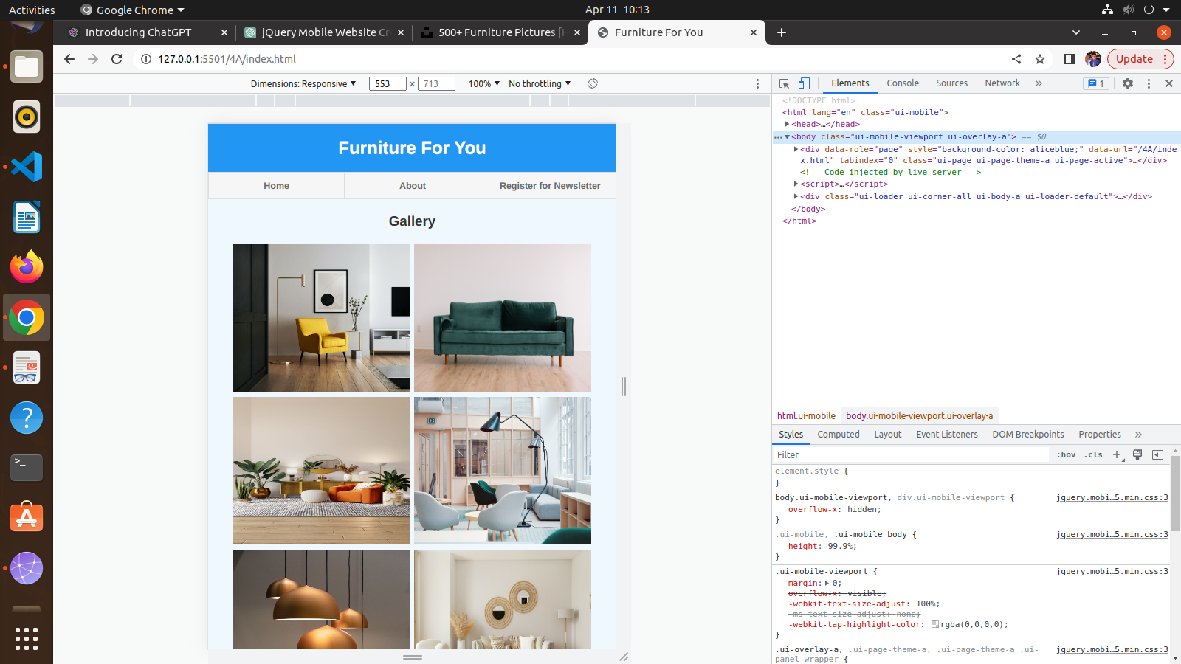
Mobile View for index.html

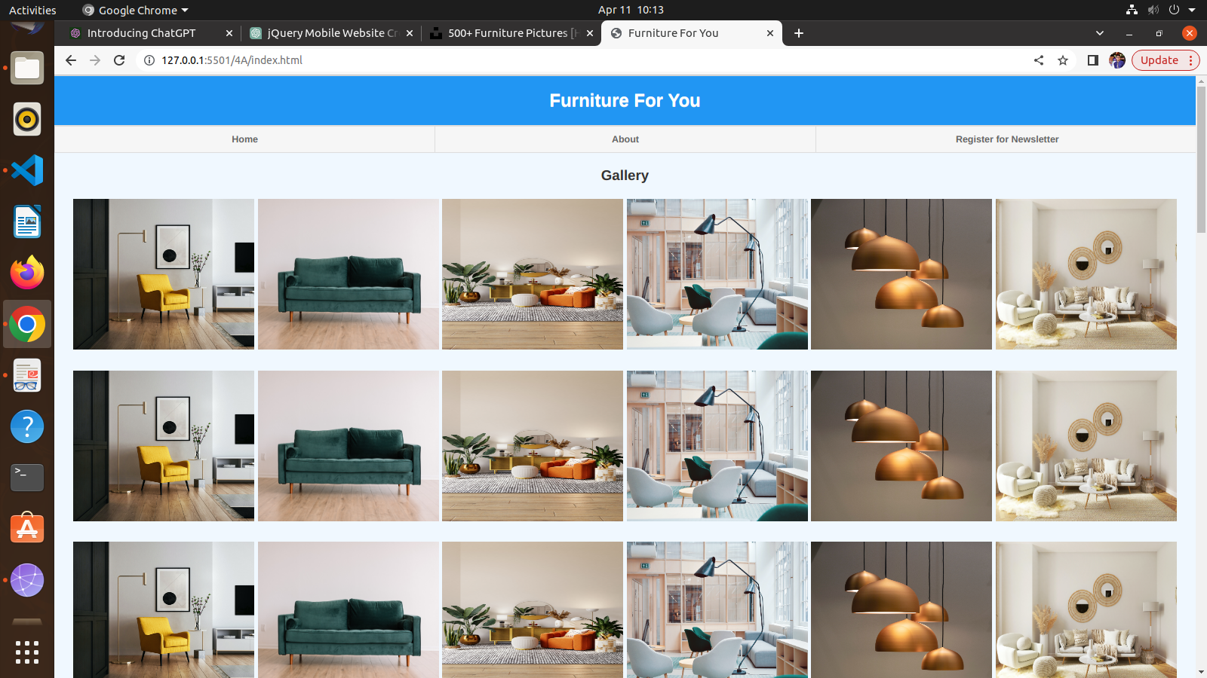

Desktop View for index.html

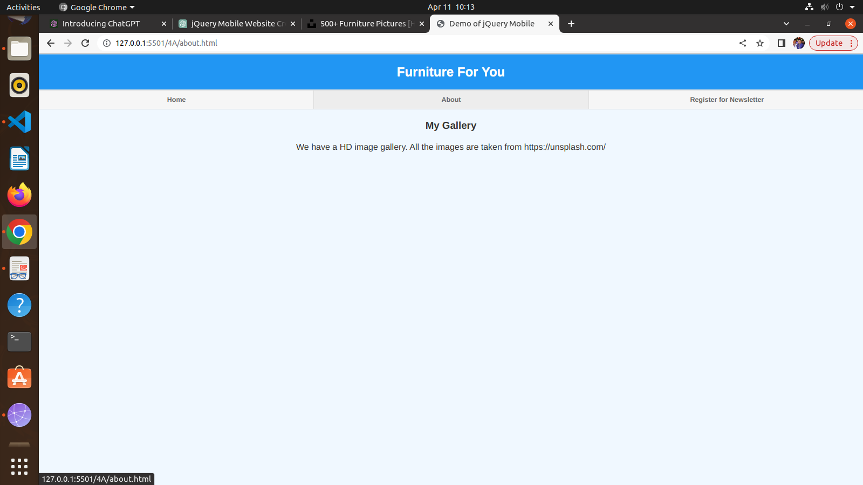
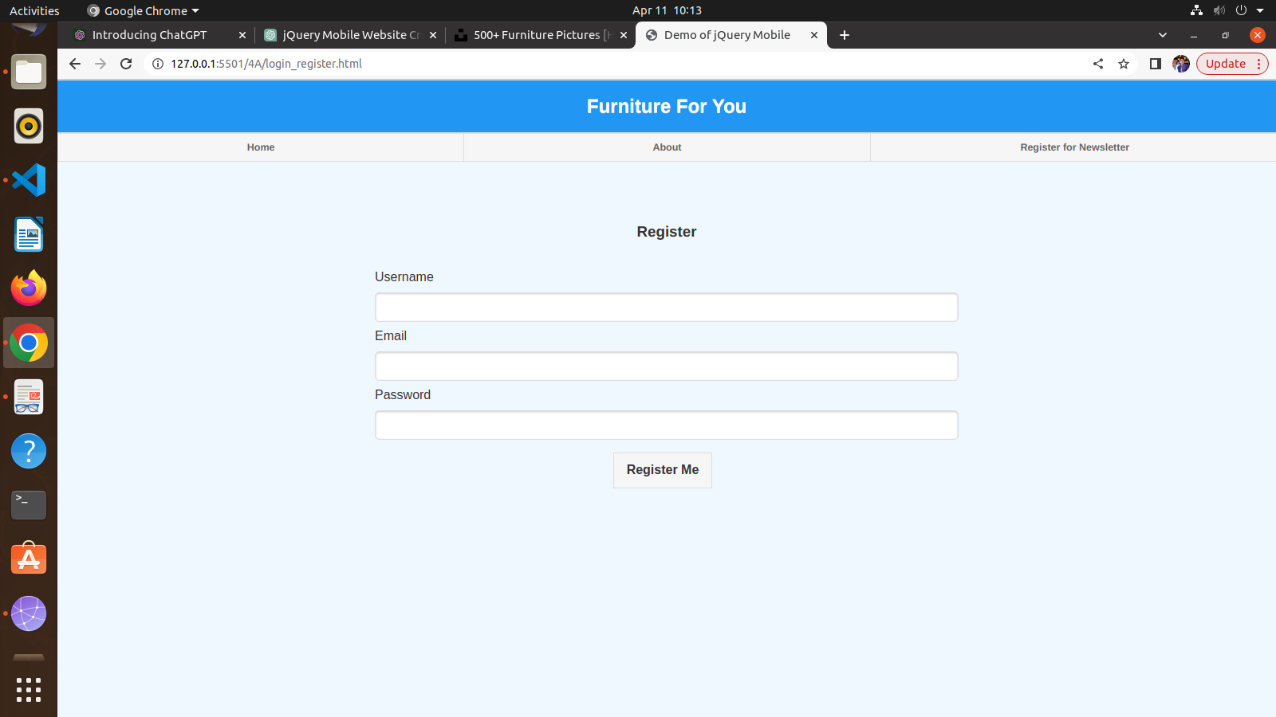
About.html

Register.hmtl

